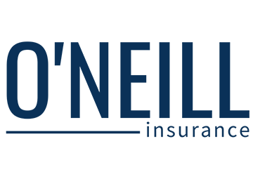
Need help picking out a health plan?
Open enrollment ends soon. However, don’t let confusion about health insurance prevent you from signing up.
Have questions about a plan or need help selecting the plan that is best for you and your family? is here to help.
Reach out to [insert contact name] in HR for help with your enrollment questions. Remember, you must sign up before [insert date] to ensure that you have health coverage beginning on [insert date].

© 2016, 2019 Zywave, Inc. All rights reserved.

