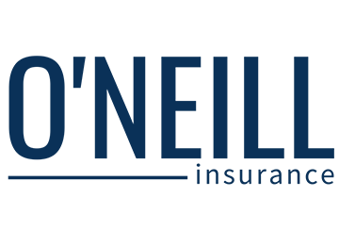
Health insurance helps you save on health care costs.
When you sign up for health insurance through , you can get coverage at some of the most competitive rates around. But open enrollment is only available for a limited time. Sign up for the plan starting [insert date] to make sure you are covered.
© 2013-2016, 2019 Zywave, Inc. All rights reserved.

