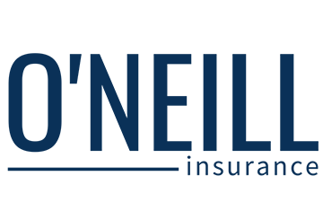
Open enrollment is over, but you can still obtain coverage.
You can no longer obtain coverage through this year, unless you experience a qualifying life event. If you don’t have health insurance, you will be responsible for 100% of your health care costs. Enroll in a health plan through the Marketplace by Dec. 15 to obtain coverage that begins Jan. 1, 2020.
Contact your The O'Neill Group representative to learn more about the Marketplace.
© 2013-2015, 2019 Zywave, Inc. All rights reserved.

